RMI Chat Server

1)ChatMachineTemplate.java
import java.rmi.*;

public interface ChatMachineTemplate extends Remote {

public String respond(String input) throws RemoteException;

}
2)ChatMachineRemote.java
import java.rmi.*;

import java.rmi.server.*;

import java.util.Scanner;

public class ChatMachineRemote extends UnicastRemoteObject implements ChatMachineTemplate {

ChatMachineRemote()throws RemoteException{

super();

}

public String respond(String input) {

Scanner s = new Scanner(System.in);

System.out.println("You have an incoming Message From The Client");

System.out.println("Client:"+input);

System.out.print("Enter Your Response:");

String output = s.nextLine();

return output;

}

}
3)MyChatServer.java
import java.rmi.*;

import java.rmi.registry.*;

public class MyChatServer{

public static void main(String args[]){

try{

ChatMachineTemplate stub=new ChatMachineRemote();

Naming.rebind("rmi://localhost:5000/chat",stub);

}catch(Exception e){

System.out.println(e);

}

}

}
4)MyChatClient.java
import java.rmi.*;

import java.util.Scanner;

public class MyChatClient{

public static void main(String args[]){

Scanner s = new Scanner(System.in);

try{

ChatMachineTemplate stub=(ChatMachineTemplate)Naming.lookup("rmi://localhost:5000/chat");

System.out.print("Enter Message to be sent to server:");

String input = s.nextLine();

System.out.println("Server:"+stub.respond(input));

}catch(Exception e){}

}

}
Output:
1)Creating Stubs
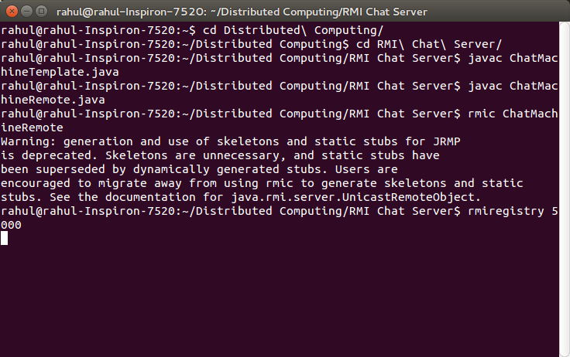
2)Server
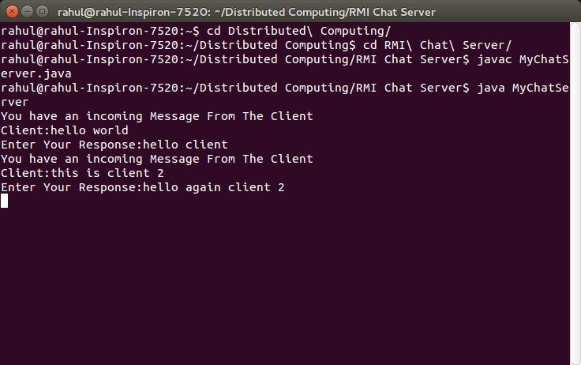

3)Client 1
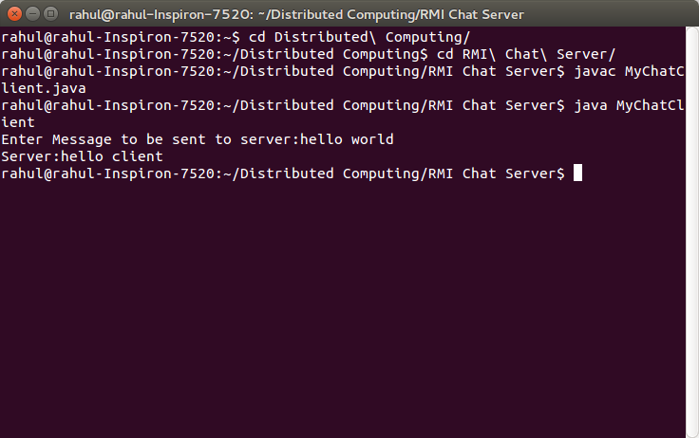
4)Client 2
